Part 7

Price system and the microeconomy

Ludovica Magni

A level

**CHAPTER 14 – THE CONCEPT OF UTILITY**

**Utility, Total Utility and Marginal Utility**

Economists use utility to explain how consumers make choices. Utility refers to the satisfaction gained from consuming a good or service. Total utility is the total satisfaction gained from consuming a given quantity, while marginal utility is the additional satisfaction from consuming one more unit. According to the law of diminishing marginal utility, marginal utility decreases as more units are consumed. Total utility rises while marginal utility is positive, reaches a maximum when marginal utility is zero, and can fall if marginal utility becomes negative.

**Marginal Utility and the Demand Curve**

When marginal utility is expressed in money terms, it links directly to the individual demand curve. A rational consumer buys units of a good until marginal utility equals price. If price falls, the consumer buys more because the marginal utility of additional units is now greater than or equal to the lower price. This explains why the marginal utility curve can be used as the demand curve.

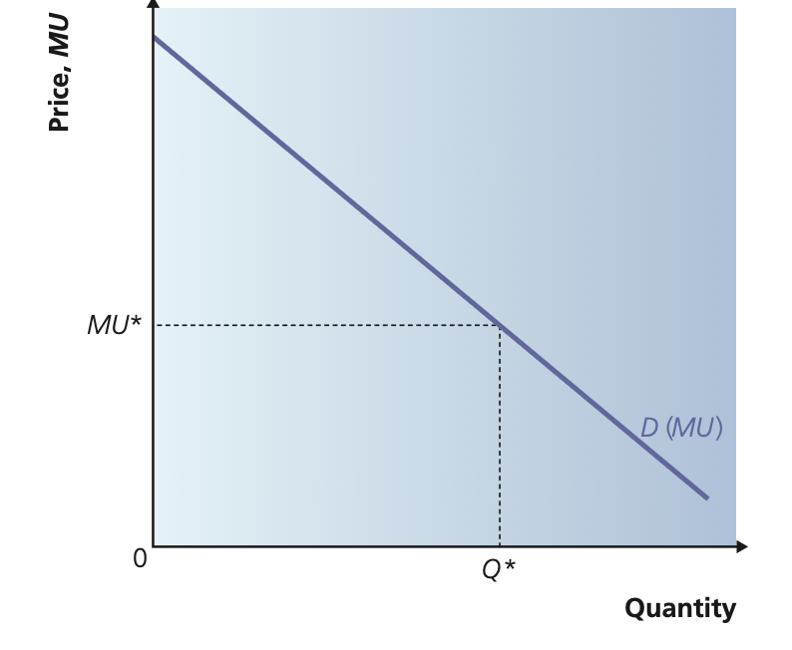

**Maximising Satisfaction: The Equi-Marginal Principle**

Since consumers buy many goods, they need to allocate their income to maximise total utility. The condition for maximum satisfaction is the equi-marginal principle:  
MUx/Px = MUy/Py.  
If marginal utility per dollar differs between goods, consumers reallocate spending to equalise these ratios. When equality is reached for all goods, total utility is maximised, and no further reallocation improves satisfaction.

**Limitations of Measurable Utility**

Utility cannot truly be measured, and consumers do not always behave rationally. Because of these limitations, economists often rely on preference-based tools such as indifference curves and budget lines to analyse consumer behaviour more realistically.

**The Budget Line**

The budget line shows all combinations of two goods that a consumer can afford at given prices and income. Its slope reflects the relative prices of the two goods. An increase in income shifts the budget line outward in a parallel way; a decrease shifts it inward. A change in the price of one good rotates the budget line around the intercept of the other good. The budget line represents the consumer’s opportunity set.

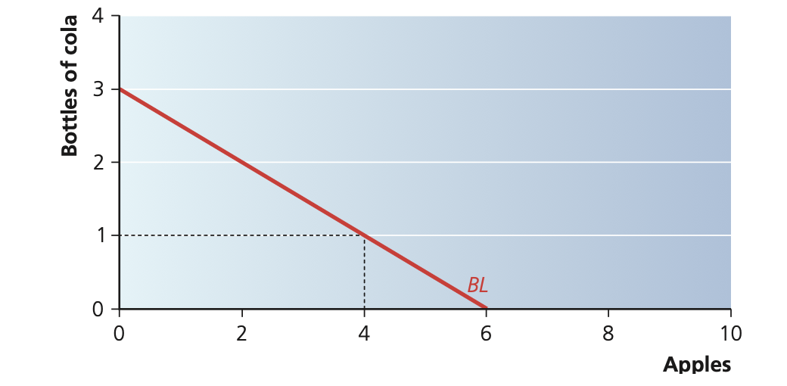

**Indifference Curves and the Marginal Rate of Substitution (MRS)**

Indifference curves represent combinations of two goods that give equal satisfaction. They slope downward and are convex because of a diminishing marginal rate of substitution. MRS measures how much of one good the consumer is willing to give up to obtain more of the other while maintaining the same overall utility. Higher indifference curves indicate higher levels of satisfaction.

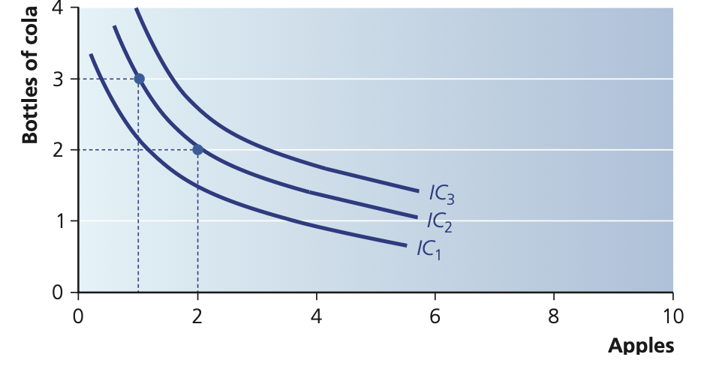

**Consumer Equilibrium**

Consumer equilibrium occurs at the tangency point between the budget line and an indifference curve. At this point, the slope of the indifference curve (MRS) equals the slope of the budget line (the price ratio Px/Py). This tangency point represents the highest satisfaction the consumer can achieve given their income. Any point inside the budget line gives lower satisfaction; any point outside is unaffordable.

**Price Changes: Substitution and Income Effects**

When the price of a good changes, the consumer moves to a new equilibrium. The substitution effect occurs because one good becomes relatively cheaper, leading the consumer to substitute toward it. The income effect occurs because a price change alters real purchasing power. For normal goods, both effects reinforce each other. For inferior goods, the income effect works in the opposite direction of the substitution effect. If the (negative) income effect is strong enough to outweigh the substitution effect, quantity demanded falls when price falls—this is a Giffen good. By observing equilibrium quantities at different prices, we can derive the consumer’s demand curve.

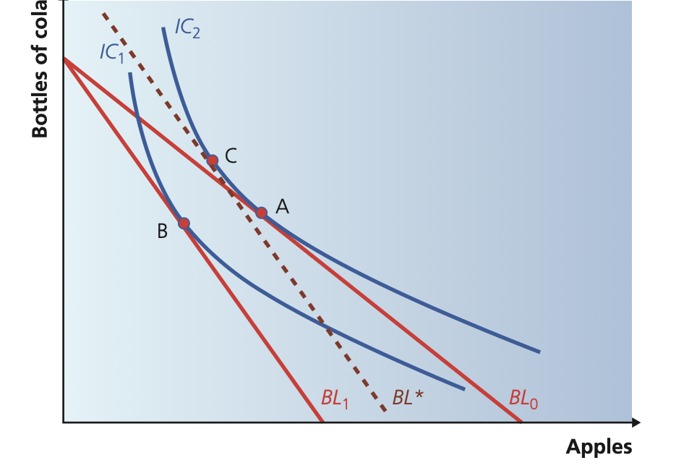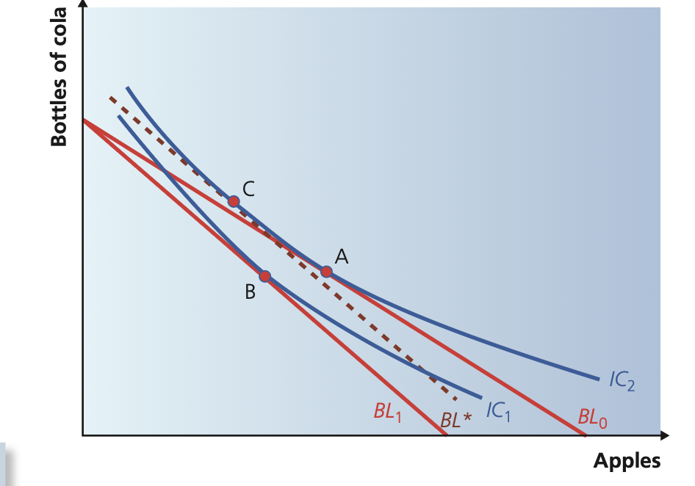

**CHAPTER 15 – EFFICIENCY AND MARKET FAILURE**

**Productive efficiency**

Occurs when firms produce at the **lowest possible average cost (AC)**.  
This happens at the **minimum point** of the AC curve.  
It means resources are used with **no waste** in production.  
Competitive markets tend to push firms toward productive efficiency in the long run because inefficient firms cannot survive.

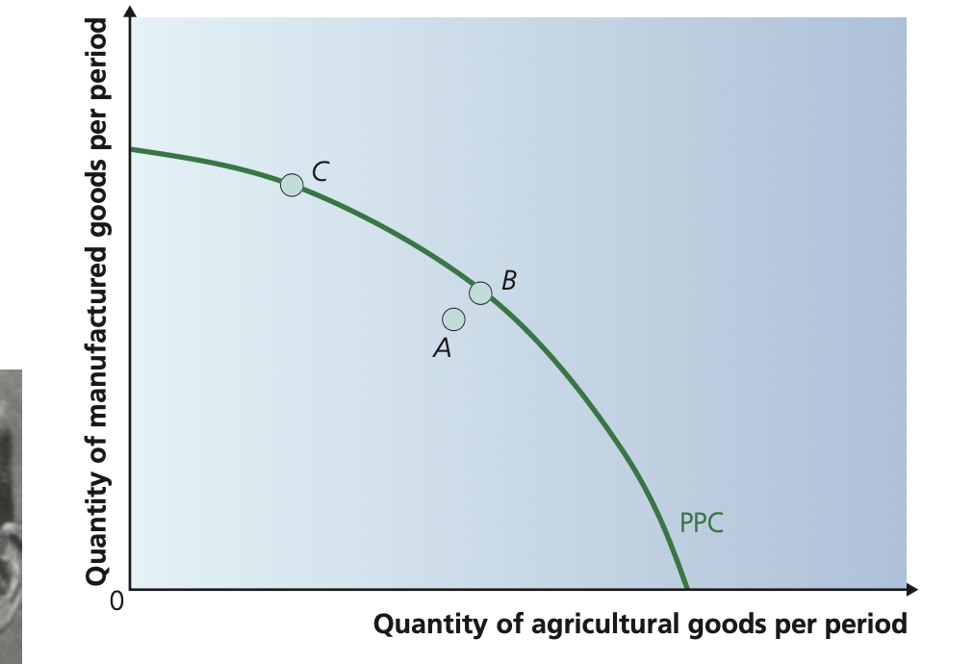

**Allocative efficiency**

Occurs when **price = marginal cost (P = MC)**.  
This means resources are allocated to produce exactly the goods and services that **maximise social welfare**.  
Consumers’ valuation of the last unit (price = marginal benefit) equals the cost of producing it (MC).  
If P > MC → underproduction  
If P < MC → overproduction  
Only perfectly competitive markets reach allocative efficiency.

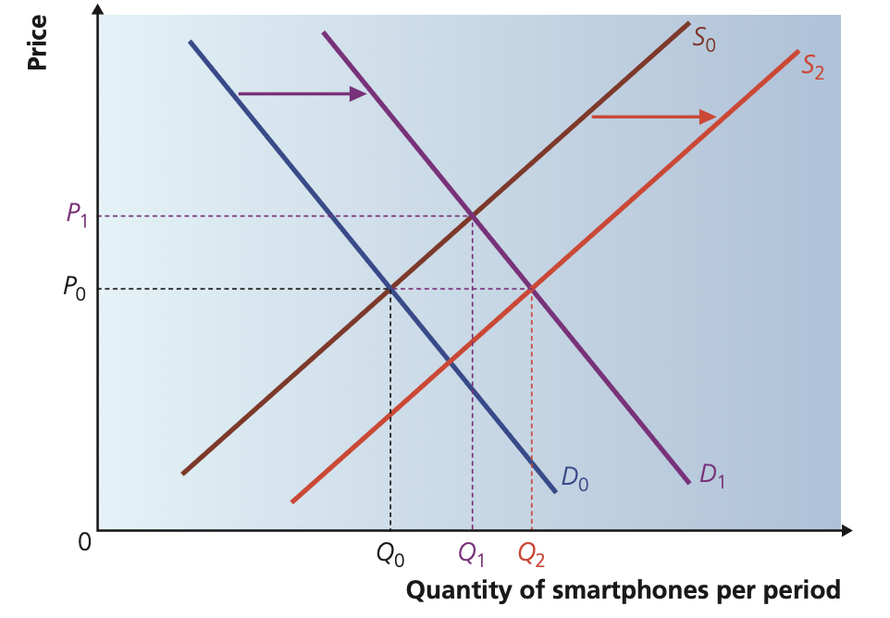

**Dynamic efficiency**

Occurs over time when firms **innovate, invest, improve technology, and reduce future costs**.  
It depends on R&D, new products, better processes, and technological progress.  
Monopolies and large firms may be dynamically efficient because they have high profits to invest.  
Perfect competition is often NOT dynamically efficient because firms have low profits and little incentive to innovate.

**X-efficiency**

When firms minimise costs even when not forced by competition.  
Occurs inside the firm.  
X-inefficiency happens when lack of competition causes costs to drift above the minimum possible level (e.g. slack, poor management, unnecessary workers).  
Monopolies often suffer from X-inefficiency.

**Static vs dynamic efficiency**

Static = productive + allocative efficiency at a point in time  
Dynamic = improvement of efficiency over time

**Efficiency & Market Failure**

Market failure occurs when markets **fail to achieve allocative efficiency**.  
This happens when MSB ≠ MSC because of:  
– externalities  
– market power (monopoly)  
– information failure  
– public goods  
– merit/demerit goods

**Social optimum**

Occurs where **MSB = MSC**.  
This is the true allocative efficiency for society.  
Divergence between private and social curves → welfare loss.

**The Circular Flow of Income**

The circular flow of income describes how money, goods, services and factors of production move through the economy. In a two-sector model, households provide factors of production (labour, land, capital and enterprise) to firms. In return, they receive income in the form of wages, rent, interest and profit. Firms use these factors to produce goods and services, which households purchase using their income. Thus income flows one way, while goods and services flow the other way. This model is fundamental in explaining how different parts of the economy are interconnected.

**Leakages and Injections**

In a more realistic economy, not all income is spent on domestic goods and services. Some income “leaks” out of the circular flow as savings (S), taxes (T), and imports (M). These are called leakages because they reduce the spending on domestic output. At the same time, the circular flow receives “injections”: investment (I), government spending (G), and exports (X). The level of national income depends on the balance between leakages and injections. National income remains stable when S + T + M = I + G + X. If injections exceed leakages, the economy expands; if leakages exceed injections, national income contracts.

**Nominal and Real Income**

Nominal income refers to the money income that households receive. Real income measures the purchasing power of nominal income—how many goods and services can be bought with it. When prices rise (inflation), real income falls unless nominal income rises equally. Distinguishing between nominal and real income is crucial for understanding living standards. A person may receive a higher salary in nominal terms, but if prices rise faster, their real income actually falls.

**Money and Its Functions**

Money is essential in the circular flow because it facilitates economic transactions. It performs four key functions: a medium of exchange, a store of value, a unit of account, and a standard of deferred payment. These characteristics allow households and firms to trade efficiently without needing barter. A stable monetary system increases confidence and allows planning, saving and investment.

**Financial Institutions and Saving**

Households save a proportion of their income instead of spending it. Savings go into financial institutions such as banks, which use these funds to lend to firms for investment. Savings are a leakage from the circular flow, but when transformed into investment, they become an injection that stimulates economic activity. Banks play an essential role by transforming savings into productive expenditure.

**Government and Taxation**

The government collects taxes from households and firms. Taxation is a leakage, reducing disposable income and consumption. However, when the government spends on public services, infrastructure, or welfare, it creates injections back into the circular flow. This spending affects national income, employment and overall economic activity. Government policy can stabilise the economy by adjusting spending and taxation levels.

**Exports and Imports**

Exports are an injection into the circular flow because they bring income from foreign buyers into the domestic economy. Imports, however, are a leakage because money flows out to purchase foreign goods. An economy with strong export demand can increase employment and income, while heavy dependence on imports can reduce domestic production.

**Equilibrium National Income**

The economy reaches equilibrium when planned spending equals output, and when leakages equal injections. If firms produce more than consumers plan to buy, inventories rise and firms reduce output. If spending exceeds output, inventories fall and firms increase production. National income adjusts to reach equilibrium through these changes in output and employment. Understanding equilibrium is essential for analyzing government policies and external shocks.

**CHAPTER 16 – PRIVATE COSTS AND BENEFITS, EXTERNALITIES AND SOCIAL COSTS AND BENEFITs**

**Private Costs and Private Benefits**

Private costs are the costs directly incurred by the individual consumer or producer involved in a transaction. For a firm, this includes wages, raw materials and operating expenses. Private benefits are the gains directly enjoyed by individuals or firms, such as revenue for producers or satisfaction for consumers. In a perfectly competitive market without distortions, decisions are based on these private costs and benefits.

**External Costs and External Benefits**

Externalities arise when production or consumption imposes costs or benefits on third parties not directly involved in the transaction. External costs (negative externalities) occur when society bears additional costs that the private decision-maker does not consider—such as pollution, traffic congestion or noise. External benefits (positive externalities) arise when third parties benefit from an activity, such as vaccination programmes, education or public parks. When externalities exist, private and social outcomes diverge.

**Social Costs and Social Benefits**

Social cost is the total cost to society of producing a good, equal to private cost plus external cost (SC = PC + EC). Social benefit is the total benefit to society from consuming a good, equal to private benefit plus external benefit (SB = PB + EB). For efficient resource allocation, output should occur where **marginal social cost (MSC) = marginal social benefit (MSB)**. If market outcomes differ from this point, society suffers from misallocation.

**Market Failure and Externalities**

Market failure occurs when free markets do not allocate resources efficiently. Externalities are one of the main causes because private agents make decisions without accounting for social effects.  
Negative externalities (like pollution) lead to **overproduction** in free markets because firms only consider marginal private cost (MPC), which is lower than marginal social cost (MSC).  
Positive externalities (like education or vaccination) lead to **underproduction**, as consumers only consider marginal private benefit (MPB), which is less than marginal social benefit (MSB).  
This divergence between private and social values means the free market output differs from the socially optimal output.

**Examples of Negative Externalities**

Environmental pollution is a classic example. Firms may emit greenhouse gases or dispose waste cheaply, imposing costs on society such as climate change, health problems or loss of biodiversity. Because these external costs are not priced, firms overproduce relative to the socially desirable level. Another example is traffic congestion, where each additional journey slows down everyone else, creating a social cost higher than the private cost faced by individual drivers.

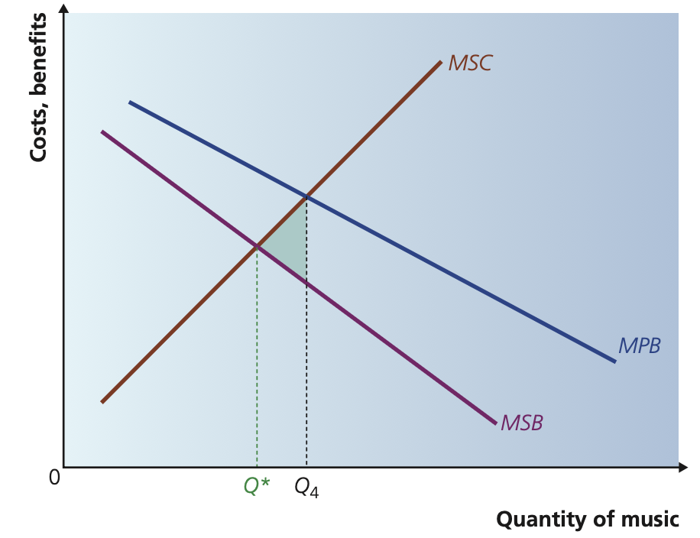

**Examples of Positive Externalities**

Vaccination programmes create benefits beyond the vaccinated individual by reducing disease transmission, improving public health and lowering healthcare costs. Education increases personal earnings but also improves productivity in the wider economy, raising overall economic performance. Because individuals do not consider these external benefits, free markets underprovide such goods unless there is government intervention.

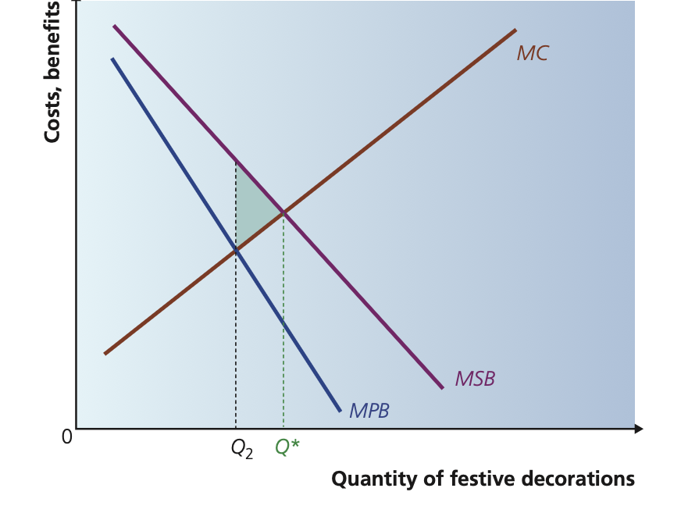

**Information Failure**

Another cause of market failure is asymmetric information, where one party in a transaction has more or better information than the other. For example, in the market for second-hand cars, sellers know more about the condition of the car than buyers. This can lead to adverse selection and market collapse. The same problem occurs in healthcare, where doctors know more than patients, and in insurance markets, where buyers know more about their own risk levels. Information failure prevents markets from reaching efficient outcomes.

**Adverse Selection and Moral Hazard**

Adverse selection occurs when the people most likely to buy insurance are those with the highest risk, causing premiums to rise and markets to become unstable. Moral hazard occurs when insured individuals take more risks because they know they are protected. For example, someone with phone insurance may be less careful with their phone. Both problems distort market outcomes and justify regulation.

**Social Cost–Benefit Analysis (SCBA)**

For large-scale public projects such as dams, highways or airports, it is essential to evaluate all private and social costs and benefits to determine whether a project should proceed. SCBA is a systematic method used by governments to judge whether the social benefits outweigh social costs. It involves several steps:

1. Identifying all direct and indirect costs and benefits, including externalities.
2. Assigning monetary values to all items, even those without market prices (shadow pricing).
3. Discounting future costs and benefits to present value since long-term projects affect multiple generations.
4. Comparing total social benefits to total social costs to decide whether the project improves overall welfare.

**Difficulties in SCBA:** Valuing externalities is challenging because many effects—such as biodiversity loss, pollution or quality of life—do not have market prices. Additionally, the choice of discount rate can alter the outcome dramatically. Political considerations may influence decisions, and different groups in society may have conflicting views about costs and benefits. Despite these difficulties, SCBA remains the most structured and transparent method for evaluating major public investments.

**CHAPTER 17 — COSTS, PRODUCTION, REVENUE & PROFIT**

**17.1 Production in the Short Run**

The short run is a period in which at least one factor of production is fixed. Usually capital is fixed while labour is variable. Because of this, firms can increase output only by using more of the variable factor. The production function describes how inputs (labour, capital, land, enterprise) are transformed into output. It shows the maximum output achievable with given quantities of inputs, assuming technology is fixed. As more units of labour are added to fixed capital, output initially increases at an increasing rate, then at a decreasing rate, and eventually marginal product falls. This pattern is explained by the **law of diminishing returns**, which states that if a firm increases a variable factor while other factors remain fixed, the marginal product of the variable factor will eventually decline. Total product (TP), average product (AP), and marginal product (MP) are used to describe output. MP cuts AP at its maximum point. AP rises when MP > AP and falls when MP < AP.

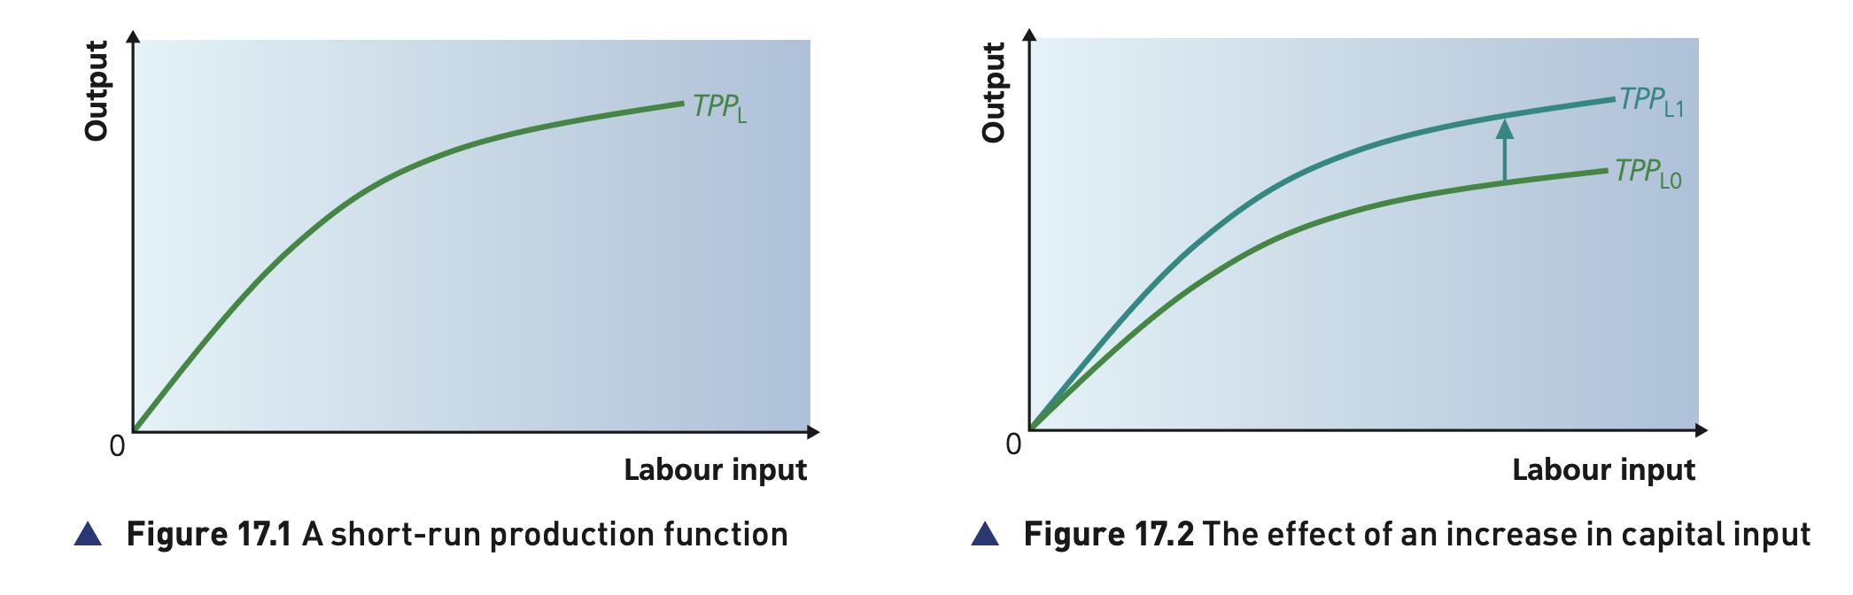

**17.2 Short-Run Costs**

Short-run costs derive directly from the short-run production function. Total cost (TC) is the sum of total fixed cost (TFC) and total variable cost (TVC). TFC does not change with output, whereas TVC increases as more output is produced. Average total cost (ATC) is TC divided by output, and has a U-shape because average fixed costs fall continuously while average variable costs eventually rise due to diminishing returns. Marginal cost (MC) is the cost of producing one more unit of output. MC falls at first, then rises sharply as diminishing returns take effect. A key relationship is that MC cuts both AVC and ATC at their minimum points. This follows from the arithmetic rule that when the marginal value is below the average, the average falls; when it is above, the average rises.

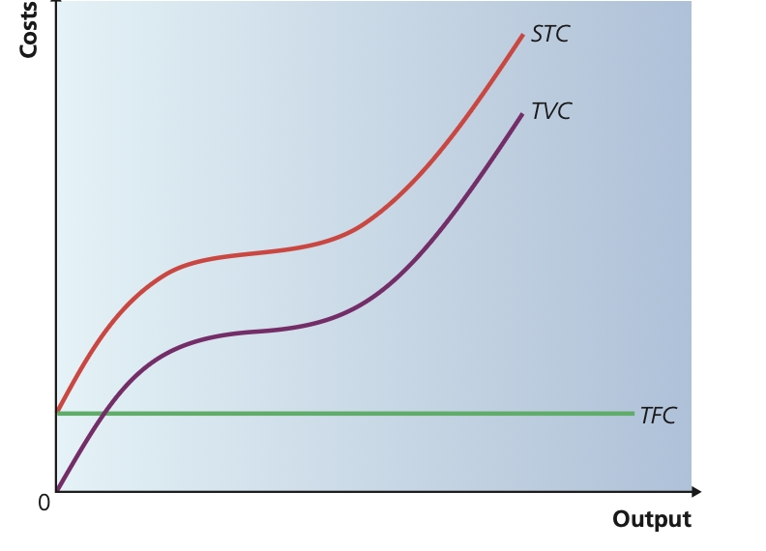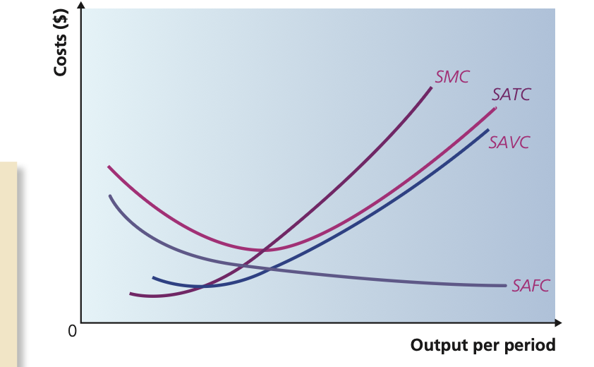

**17.3 Long-Run Production and Costs**

The long run is a period in which all factors of production are variable. Firms can choose the most efficient scale of production. The **long-run average cost curve (LRAC)** is derived from the envelope of many possible short-run average cost curves, each representing a different scale of plant or machinery. LRAC is usually U-shaped because of **economies and diseconomies of scale**. Economies of scale cause LRAC to fall when output increases. They include technical economies (more efficient machinery), managerial economies (specialised management), purchasing economies (bulk buying), financial economies, and marketing economies. Diseconomies of scale occur when a firm becomes too large and organisational or coordination problems cause LRAC to rise again. The lowest point on the LRAC is the **minimum efficient scale (MES)**, which represents the smallest output level at which the firm can fully exploit economies of scale. Market structure is closely related to MES: industries with very large MES tend to become monopolies or oligopolies.

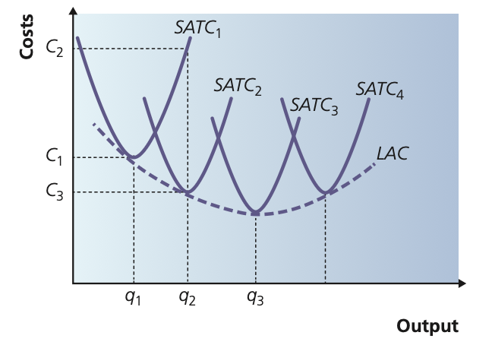

**17.4 Revenue**

A firm’s revenue comes from selling its output. Total revenue (TR) is price multiplied by quantity sold. Average revenue (AR) is TR divided by quantity, and equals the market price when the firm is a price taker. Marginal revenue (MR) is the change in TR from selling one more unit. In perfect competition MR = AR = price. Under imperfect competition, the demand curve slopes downward, so MR lies below AR because lowering price to sell more units reduces revenue received from previous units.

**17.5 Profit**

Profit is the difference between total revenue and total cost. **Normal profit** occurs when TR = TC, meaning the firm covers all its opportunity costs. This is the minimum profit needed to keep resources in the industry. **Supernormal (abnormal) profit** exists when TR > TC, attracting new firms into the industry in the long run. **Subnormal profit** occurs when TR < TC. The **shutdown rule** states that in the short run a firm should continue to produce as long as price covers average variable cost (P ≥ AVC), because fixed costs must be paid anyway. In the long run, a firm must cover total costs (P ≥ ATC) or it will leave the market.

**17.6 Profit Maximisation**

Most economic theory assumes that firms aim to maximise profit. Profit is maximised where **MR = MC**, meaning the revenue gained from the last unit sold equals the cost of producing it. If MR > MC, the firm should increase output; if MR < MC, it should reduce output. The condition MR = MC determines the profit-maximising level of output for firms in all market structures. In perfect competition, the firm produces where MR = MC = price, while in monopoly and imperfect competition, the firm chooses an output where MR = MC and sets the price on its demand curve.

**CHAPTER 18: DIFFERENT MARKET STRUCTURE**

Market structure describes the characteristics of a market that influence the behaviour of firms, including numbers of firms, level of competition, barriers to entry, the type of product, and the degree of market power. Different market structures determine how firms set prices, how much output they produce, and how efficiently resources are allocated.

* **Perfect Competition**

A perfectly competitive market has many small firms (chocolate production), each producing identical goods. No single firm has market power. Entry and exit are free, and all firms and consumers have perfect information. Because each firm is a price taker, it must accept the market price determined by the intersection of industry supply and demand.

The firm’s demand curve is perfectly elastic, meaning AR=MR=Price.

* **In the short run**: firms can make supernormal profit (above normal one, price 〉 AC) normal profit (firms cover all costs Price 〉 AC) or losses (subnormal profit AC 〉 Price).

**Short-run industry equilibrium is determined by price**, which is set by the interaction of market supply and demand. **Individual firms are price takers** because no single firm can influence the market price.

Each firm chooses only its quantity of output and will produce at the **profit-maximising point where MR = MC**.

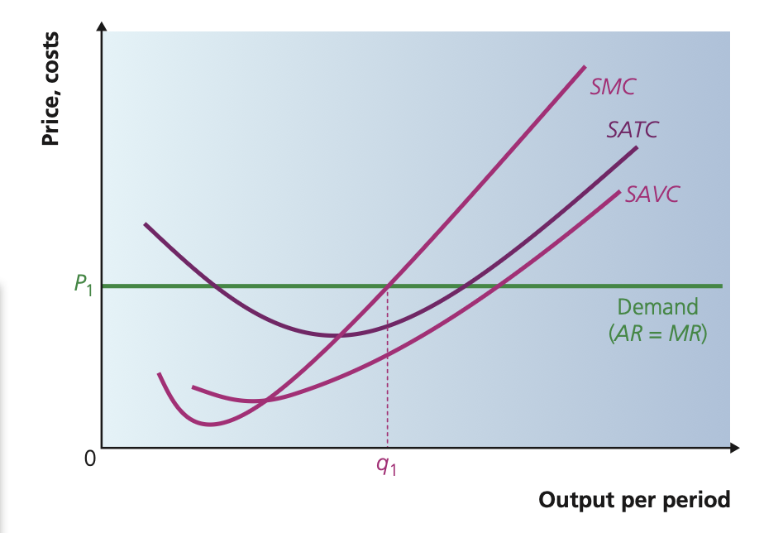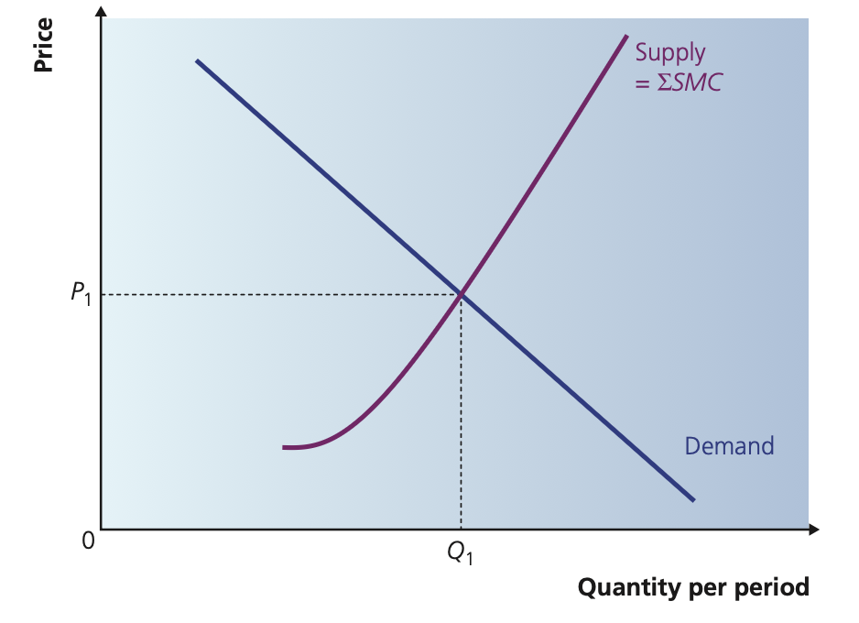

* 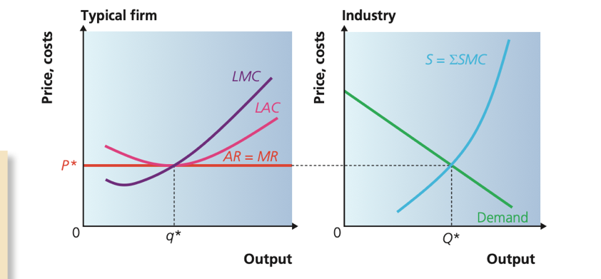**In the long run, all factors of production are variable, and firms can freely enter or exit the market.**  
  Because there are no barriers to entry, any **supernormal profit** attracts new firms into the industry. As new firms enter, **industry supply shifts to the right**, causing the market price to fall. Entry continues until all firms earn **normal profit** (P = AC).

If firms are making **losses**, some will exit the market. Exit causes **industry supply to shift to the left**, raising the market price. This process continues until losses are eliminated and firms again earn **normal profit**.

**Long-run equilibrium** occurs when **there is no incentive for firms to enter or exit** the industry. At this point:

* firms earn **normal profit** (P = minimum AC)
* firms operate at the **minimum point of their AC curve**, achieving **productive efficiency**
* price equals marginal cost (P = MC), so the market also achieves **allocative efficiency**

Perfect competition therefore represents the **benchmark of efficiency** in economic theory.

* **Monopoly**

A monopoly is a market structure in which a single firm dominates the market and supplies the entire output of a good or service. The monopolist faces the market demand curve directly and therefore has significant control over price. Because there are strong barriers to entry, other firms cannot easily enter the industry, so the monopolist can maintain its position and continue to earn supernormal profit in the long run.

**Assumptions of the monopoly model**

The standard theory of monopoly is built on four main assumptions. First, the firm aims to maximise profit. Second, there is a single seller of the good, so the firm is the industry. Third, there are no close substitutes for the good, either actual or potential; consumers who want that product have to buy from the monopolist. Fourth, there are barriers to entry that prevent new firms from entering the market and competing away profits. Because there are no close substitutes and entry is blocked, the monopolist is insulated from competition and can behave as a price maker.

**Barriers to entry**

Barriers to entry are any factors that make it difficult or impossible for new firms to enter an industry. In monopoly they are crucial, because they allow the firm to keep its market power. Several types of barriers are important.

* Economies of scale can act as a barrier. If the minimum efficient scale of production is very large relative to the size of the market, a single large firm can produce at a much lower average cost than any smaller entrant. A new firm would have higher costs and could not match the monopolist’s price, so it will be deterred from entering.
* High fixed costs are another barrier. Where set-up costs are very large relative to marginal costs, a potential entrant would need to invest heavily before producing anything. Knowing that the incumbent can spread these fixed costs over a large output, the entrant may judge the risk too high and stay out of the market.
* Cost advantages can also protect a monopoly. The firm may have access to a cheaper raw material, a superior production process, or a better location that reduces transport and distribution costs. These advantages allow it to produce at lower average cost than potential rivals.
* Government regulation is often a legal barrier. Through patents, copyright and licenses the state can grant a firm the exclusive right to produce a good for a period of time. This is intended to reward innovation and encourage research and development, but it also creates a legal monopoly while the protection lasts.
* Switching costs can work as a barrier from the consumer side. If customers face high costs in moving to a rival supplier, for example having to learn a new software system or losing compatibility with existing users, they may prefer to remain with the incumbent firm even if alternatives appear.
* Strategic action by the incumbent can deliberately raise barriers. The monopolist may invest in spare capacity, heavy advertising or research and development to signal strength and deter entry. It might also build up a reputation for cutting prices aggressively if a new firm enters, making potential rivals reluctant to try.
* Network effects arise when the value of a product increases with the number of users. For example, social media platforms or software formats become more attractive the more people use them. A firm that achieves a large user base benefit from a self-reinforcing advantage that makes it hard for new firms to compete, since consumers prefer to join the largest network.

**Demand, revenue and the price-making role**

Because the monopolist is the only seller, the market demand curve is its own demand (or average revenue) curve. This curve slopes downwards: to sell a higher quantity the firm must lower the price. As a result, marginal revenue lies below average revenue. When the firm cuts price to sell an extra unit, it gains revenue on that extra unit but loses some revenue on all the previous units which are now sold at a lower price. This is why MR falls faster than AR.

The monopolist is a price maker. It chooses the profit-maximising quantity where marginal revenue equals marginal cost, then uses the demand curve to find the highest price that consumers are willing to pay for that quantity. Price therefore lies above marginal cost.

**Profit maximization and supernormal profit**

Under monopoly, profit maximization occurs at the output where MR = MC.

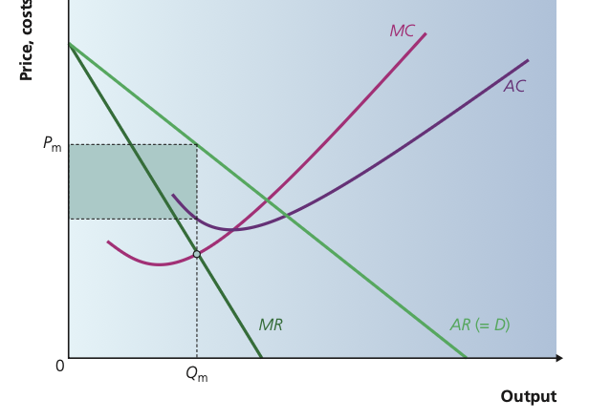Suppose this occurs at quantity Qm. The firm then charges price Pm, found by going up from Qm to the demand (AR) curve. Average cost at that output is given by the AC curve. As long as price is above average cost, the firm earns supernormal profit equal to the rectangle (Pm – AC) times Qm. Because barriers to entry prevent other firms from entering and competing away these profits, the monopolist can continue to earn supernormal profit even in the long run.

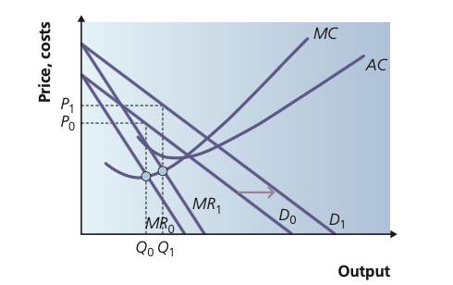**A monopoly and an increase in demand**

If demand for the monopolist’s product increases, the demand (AR) curve shifts to the right and the MR curve shifts to the right as well, maintaining the same relationship. The firm still maximizes profit where MR = MC, but this now occurs at a higher output. Moving up to the new demand curve gives a new, higher profit-maximising price. Both output and price rise, and supernormal profit increases. This shows why a monopolist may have strong incentives to increase demand through advertising, product development or marketing.

**How monopolies arise**

Monopolies can be created in several ways. Sometimes a legal monopoly is granted directly by the authorities, for example a state postal service or a national electricity provider given exclusive rights to operate. Patents can create a temporary monopoly when a firm develops a new product or process, and other firms are legally prevented from copying it. Monopolies may also arise through internal growth as a successful firm expands and uses economies of scale, gradually gaining such a large market share that rivals cannot compete. In other cases, monopolies are created through mergers and acquisitions, when one firm buys out its competitors or combines with them to exploit economies of scale and scope. Strong brand loyalty and network effects can also lead to a monopoly-like position, as consumers gravitate to a dominant brand or platform.

**Natural monopoly**

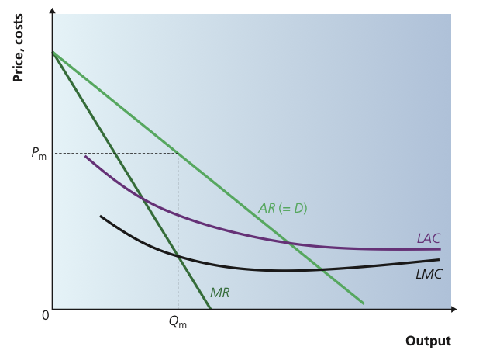A natural monopoly occurs in an industry where there are such substantial economies of scale that only one firm is viable in the market. In these industries the long-run average cost curve falls over the entire range of relevant output. If more than one firm tried to operate, each would produce on a smaller scale and at a higher average cost, so duplication of infrastructure would waste resources. Typical examples include water supply, electricity transmission or underground railways, where fixed costs of building networks are extremely high but marginal cost of serving an extra customer is low.

In a natural monopoly the existing firm can always produce at a lower average cost than any potential entrant. This acts as a powerful barrier to entry. The natural monopolist still chooses output where MR = MC and sets price from the demand curve, but from society’s point of view there may be a trade-off: one large firm avoids the high costs of duplication, yet at the same time the monopolist may restrict output and charge a price above marginal cost.

**Monopoly and efficiency**

The efficiency of monopoly can be assessed in terms of productive and allocative efficiency, and by comparison with perfect competition.

* Productive efficiency is achieved when a firm produces at the minimum point of its long-run average cost curve. A monopolist maximising profit where MR = MC is very unlikely to produce exactly at this point; more often it will operate at a level of output where average cost is above its minimum. Lack of competitive pressure can also lead to X-inefficiency: the firm may not minimize its costs because managers and workers have less incentive to control waste or work at maximum efficiency-.
* Allocative efficiency is achieved when price equals marginal cost, so that resources are allocated to produce the combination of goods and services most valued by consumers. In monopoly, price is set above marginal cost. The monopolist restricts output below the competitive level and charges a higher price. Compared with a perfectly competitive industry with the same cost conditions, monopoly results in lower output and higher price. Part of the consumer surplus that would exist under perfect competition is transferred to the monopolist as supernormal profit, and part is lost altogether as a deadweight welfare loss. This welfare loss is represented by the triangle between the monopoly and competitive quantities and prices on the diagram.

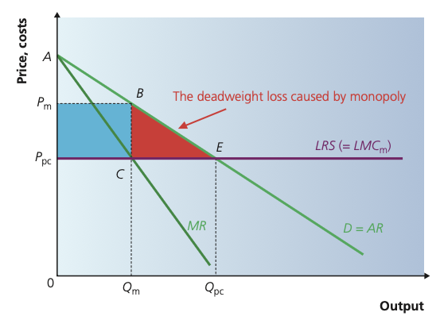

There is therefore a clear allocative and productive efficiency loss from monopoly, but this can be partly offset in some cases. A monopoly that benefits from large economies of scale may have lower average costs than a fragmented competitive industry. In addition, the prospect of supernormal profits can encourage research, innovation and dynamic efficiency. Overall, the impact of monopoly on welfare depends on the balance between these potential efficiency gains and the costs of higher prices, restricted output and possible X-inefficiency.

**CHAPTER 19 - DIFFERENT MARKET STRUCTURES:**

**MONOPOLISTIC COMPETITION AND OLIGOPOLY**

* **Monopolistic Competition**

Monopolistic competition is a market structure where there are many firms, each selling products that are similar but not identical. Because of product differentiation, each firm has some degree of market power, meaning it can slightly influence its own price. However, the presence of many competitors and the freedom of entry and exit prevent firms from earning long-term supernormal profits. Firms spend heavily on branding, packaging, quality differences, advertising and customer experience in order to make consumers perceive their product as different.

**In the short run**, a firm in monopolistic competition behaves similarly to a monopoly: it faces a downward-sloping demand curve, so its marginal revenue lies below average revenue. The firm maximises profit where MR = MC and sets the corresponding price on the demand curve. This allows short-run supernormal profit if the price is greater than average cost. However, because barriers to entry are low, new firms are attracted by the possibility of profit. As they enter, the demand curve faced by each existing firm shifts inward until it becomes tangent to the average cost curve. At that point, in the long run, the firm earns only normal profit. Output is lower and price is higher than under perfect competition, meaning neither productive nor allocative efficiency is achieved. Nevertheless, consumers benefit from variety, which is the main strength of monopolistic competition.

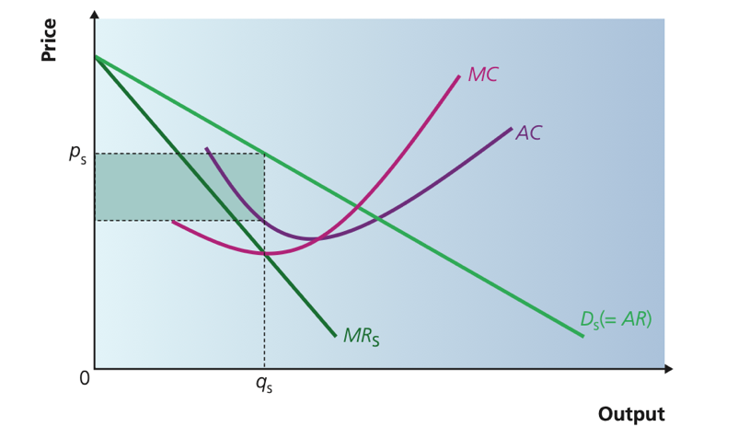

**Product Differentiation**

Product differentiation means that although firms sell similar goods, they are not identical. This difference can be based on physical variations, branding, location, quality, after-sales service or any factor that makes consumers prefer one product over another. Because of differentiation, each firm faces its own demand curve and has some price-setting ability. Firms use advertising and marketing to reinforce these differences and increase customer loyalty. Differentiation is central to the structure because it explains why firms have market power and why the demand curve is downward sloping instead of perfectly elastic.

**Short-Run and Long-Run Equilibrium**

In the short run, the firm chooses the quantity where marginal revenue equals marginal cost. The price is determined on the demand curve above marginal cost, so the firm can earn supernormal profit. In the long run, entry of new firms shifts the demand curve leftwards and makes it tangent to the average cost curve. At this tangency point, the firm earns normal profit, and no further entry or exit happens. The long-run equilibrium occurs where the firm produces at an output lower than the minimum point of its AC curve (excess capacity), meaning productive efficiency is not achieved. Price exceeds marginal cost, so allocative efficiency also is not achieved.

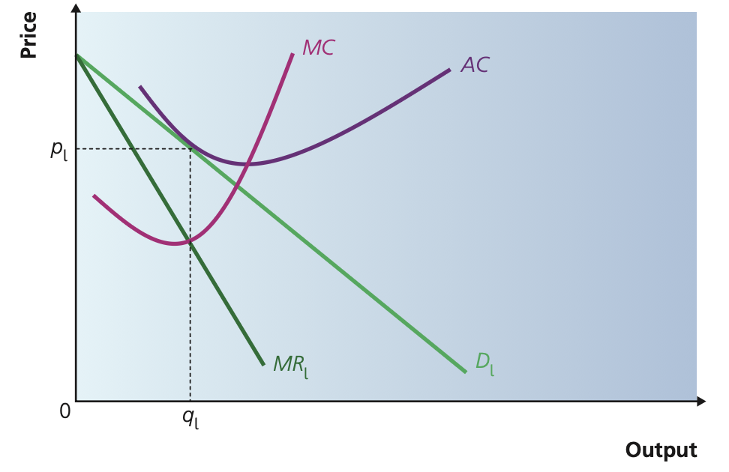

**Efficiency in Monopolistic Competition**

Monopolistic competition is not productively efficient because firms operate with excess capacity: they do not produce at the minimum point of their AC curve. They are not allocatively efficient because price is greater than marginal cost. However, variety and consumer choice may justify these inefficiencies. Firms may also be dynamically efficient if they innovate through advertising, design, technology or quality improvements, but this effect is smaller than in monopoly or oligopoly because profits are competed away in the long run.

* **Oligopoly**

Oligopoly is a market structure dominated by a small number of interdependent firms. Because there are only a few major players, each firm’s decisions affect the others, leading to strategic behaviour. Barriers to entry tend to be high, often due to economies of scale, brand loyalty, patents or strategic actions. Oligopolies face a downward-sloping demand curve, but the exact shape depends on whether firms compete aggressively or collude. The key feature of oligopoly is interdependence, meaning firms must consider the possible reactions of rivals before changing price, output or marketing strategy.

**Non-Price Competition**

Oligopolists often avoid price wars because price cuts are usually matched by rivals, reducing profits for all. Instead, they compete using non-price strategies such as advertising, product innovation, customer loyalty programmes, packaging, quality improvements or better service. Non-price competition helps firms increase market share without triggering destructive price competition. Because these strategies can be expensive, large oligopolistic firms benefit from their high profits and economies of scale to sustain them.

**Game Theory and the Prisoners’ Dilemma**

Game theory is used to explain strategic behaviour in oligopoly. The Prisoners’ Dilemma shows how two firms acting in their own self-interest can end up with a worse outcome than if they had cooperated. In price competition, although both firms would earn higher profits by keeping high prices, each has an incentive to undercut the other, leading both to low profits. This model explains why oligopolies try to avoid price competition and prefer non-price strategies or implicit forms of coordination.

**The Pay-Off Matrix**

A pay-off matrix presents the possible outcomes of the decisions made by two firms. Each cell shows the profits depending on whether each firm chooses high price or low price. The dominant strategy is the best option regardless of the opponent’s choice. In many oligopoly situations, the dominant strategy leads to a Nash equilibrium where both firms choose low prices, even though this is worse than mutual cooperation. This demonstrates the instability of collusive agreements and the difficulty of maintaining high prices without regulation.

**Contestable Markets**

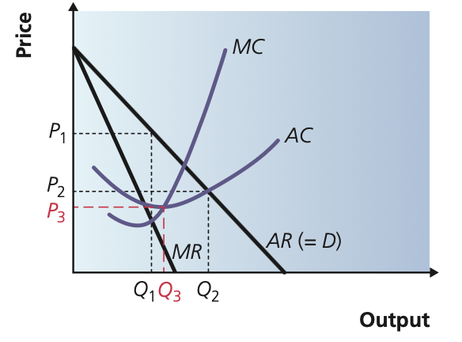A contestable market is one where the threat of entry is strong enough to force firms to behave competitively, even if the market is technically dominated by few firms. The key condition for contestability is the absence of barriers to entry and exit. If firms can enter and leave easily, incumbents will charge prices close to average cost to avoid being undercut. Therefore, even a monopolist in a contestable market may produce efficiently. Contestability increases competitive pressure, reduces excess profits and improves both productive and allocative efficiency.

**Market Concentration and Concentration Ratios**

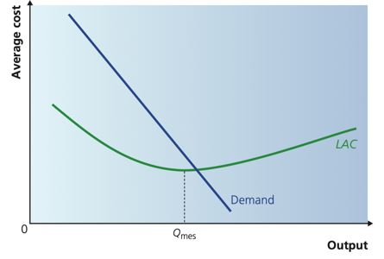Market concentration measures how much of the market is controlled by the largest firms. A commonly used measure is the concentration ratio, which adds together the market shares of the largest X firms in the industry (e.g., CR4 = the market share of the top four firms). A high concentration ratio indicates oligopoly or monopoly power, whereas a low ratio indicates competitive markets. Concentration ratios help regulators decide whether a market is too dominated and whether intervention is needed to encourage competition.

**Market Dominance**

Market dominance occurs when a firm has a large share of the market and can influence price, output or market conditions. Dominant firms may exploit market power through high prices, limit price strategies, predatory pricingor heavy advertising. Competition authorities monitor dominant firms to prevent abuse of power and protect consumer welfare.

**CHAPTER 20 – THE GROWTH AND OBJECTIVES OF FIRMS**

*How does a firm grow and survive while competing with others?*

**Firm Growth**  
Firms aim to grow in order to increase profit, reduce competition, gain market power, and exploit economies of scale. Growth also helps firms survive in competitive markets and achieve long-term success. A growing firm can lower costs, strengthen its brand, and become more efficient.

* **Organic (Internal) Growth**  
  Organic growth happens when a firm expands using its own resources, such as opening new branches, investing in new products, or improving technology. It is safer and keeps full control inside the company, but the growth is slower compared to expansion through other firms.
* **External Growth: Mergers and Takeovers**  
  External growth occurs when firms expand by joining with or buying other firms. A merger happens when two firms agree to combine, while a takeover happens when one firm buys control of another. This growth is quicker but riskier due to integration problems and cultural conflicts.

**Different types of Integration:**

* **Horizontal Integration** is when a firm merges with or takes over another firm in the same stage of production, such as two competing supermarkets. It increases market share, reduces competition, and allows greater economies of scale — but may lead to monopoly concerns. (Pepsi and Coca Cola)
* Vertical forward integration is when a firm takes control of the distribution process, like a manufacturer buying retail shops, to control how products reach consumers. (coffee industry and a caffee)
* Vertical backward integration is when a firm takes control of its supply chain, like a coffee shop buying coffee farms, to lower costs and secure raw materials. (Starbuck and coffee farm).
* Conglomerate integration occurs when firms in completely different industries merge. This helps diversify risk and increase stability because the firm no longer depends on a single market. However, lack of experience in the new industry increases uncertainty. (Amazon and Starbucks).

**Cartels**  
A cartel is when competing firms secretly agree to fix prices, limit output, or divide markets. This allows them to behave like a monopoly, charging high prices and reducing consumer welfare. Cartels are illegal in most countries because they reduce competition and efficiency.

* Managers in a cartel may cheat on the agreement because they personally benefit in the short run. Even if cheating hurts the firm and its owners long-term.

**Principal–Agent Problem**  
In large firms, the owners (principals) want to maximise profit, while managers (agents) may focus on personal goals like bonuses or job security. This separation creates conflicts of interest and inefficiency unless incentives are aligned.

**Owners** (principals) want the firm to **maximise profit** and increase firm value.  
These goals are **the same as the firm’s main objectives.**

**Objectives of Firms**  
Not all firms focus only on profit. Some aim to maximise revenue, or to grow market share by selling larger output. Others may “satisfice”, meaning earning enough profit while balancing workers’ happiness or social responsibility. The objective depends on market structure and business priorities.

* 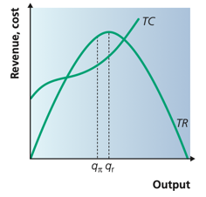**Behavioral Theories and Satisficing**  
  Behavioral economics argue that firms and managers do not always act rationally. Instead of always maximising profit, they may choose strategies that are simply “good enough”. This satisficing behavior happens due to limited information, stress, or avoiding risks.
* 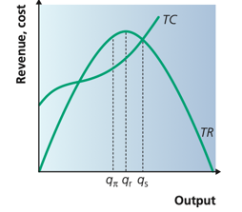**Revenue Maximisation**  
  A firm focusing on revenue maximization wants the highest possible total revenue rather than maximum profit. This often involves lowering price to increase sales. It may be used to increase market share or discourage new firms from entering the market.
* **Sales Volume Maximisation**  
  Some firms aim to maximise the number of units sold. The goal is to expand market presence and grow consumer loyalty, even if profits are lower. This is common in highly competitive markets or where firms want long-term dominance.
* **Utility Maximisation**  
  Utility maximization refers to decisions made to increase satisfaction or happiness rather than financial gain. This is more relevant to managers or consumers than firms, but it can influence business choices such as ethical production or improved working conditions.

**HOW?**

* 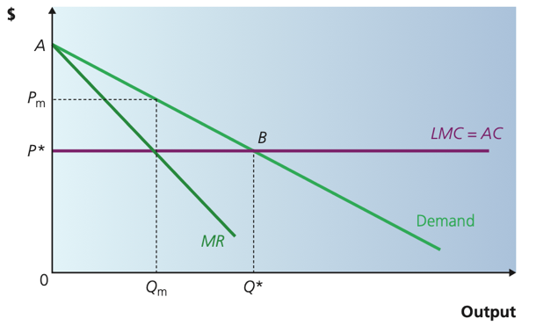**Price Discrimination**  
  Price discrimination is when a firm charges different prices for the same product to different customers, depending on willingness to pay. It increases profit by capturing more consumer surplus. It is only possible with market power, differentiated customers, and barriers to resale.
* 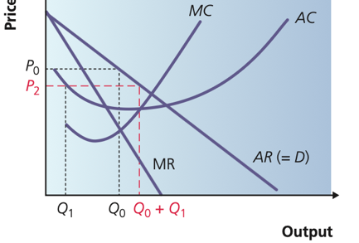**Limit Pricing**  
  Limit pricing happens when an established firm sets prices low enough to make entry unprofitable for new competitors. The aim is to protect market share. The firm does not maximise short-run profit but maximizes long-term survival.
* **Predatory Pricing**  
  Predatory pricing occurs when a firm deliberately sets prices below cost to force rivals out of the market. After competitors exit, the firm raises prices again. It is illegal in many economies because it reduces competition and harms consumers in the long run.
* **Price Leadership**  
  In an oligopoly, the largest firm may set the price while other firms follow. This avoids price wars and creates stability. Smaller firms accept the leader’s pricing because competing aggressively would harm everyone.
* 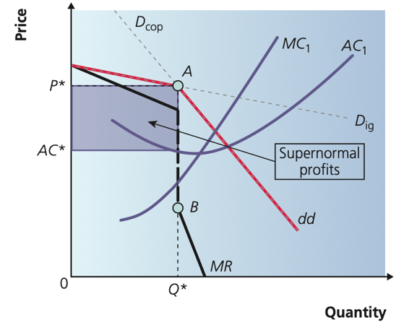**Kinked Demand Curve**  
  The kinked demand curve model explains why prices in an oligopoly are rigid. If a firm raises its price, competitors do not follow, so demand becomes elastic, and customers switch away. If a firm cuts its price, competitors match the cut, making demand inelastic and reducing revenue. Therefore, firms avoid changing prices and instead compete through advertising and product differentiation.